REPORT SUMMARY

Data transformation issues identified :
- Row count mismatch (8,633 extra rows in target)
- Duplicate data (8,633 duplicate records)
- Data completeness validation working
Jenkins credantials:
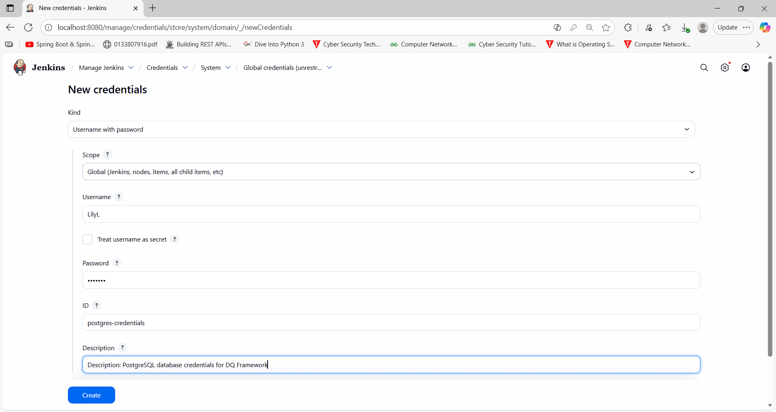
Successful run report:
